First Last
Title
000.000.0000
email@berry.edu
BERRY.EDU

-------------------------------------------------------------------------------------------------------------------------------
Setting up your Berry College email signature

IMPORTANT FIRST NOTE: This Word document should be downloaded to your machine to properly select the signature configuration above. For Windows users, this can also be done by simply clicking the ENABLE EDITING button OR selecting EDIT DOCUMENT from the VIEW menu if you are viewing this document in web view.

Outlook for Windows Instructions
- Open Outlook and click the FILE > OPTIONS menu
- Inside the OPTIONS window select the MAIL category on the left and then click the SIGNATURES button from the resulting right side options pane
- Click the NEW button in the SIGNATURES window and type a name for the new signature
- Copy the signature template from the top of this document per the following instructions:
  - Click inside the text to display the table selection icon at the top left of the signature
  - Click on that icon to select the entire signature (do not remove the empty left column)
  - Right click on any area of the gray highlight and choose COPY from the related menu
- In Outlook, right click inside the Outlook EDIT SIGNATURE box and paste the copied signature
- Edit the name and contact information for the signature one line at a time
- Click inside the column to the left of the vertical line to place the selected Berry logo
- Click the INSERT IMAGE button and choose the preferred logo that was downloaded to your computer – once selected click the INSERT button
- To set this new signature as your default, select the name you chose in step three above from the NEW MESSAGES drop down at the top right side of the SIGNATURES window
- Click OK to save
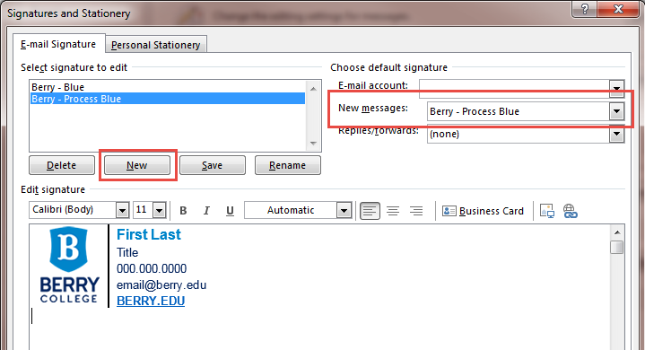
Outlook for Mac Instructions
- With Outlook open, click on the OUTLOOK menu and choose PREFERENCES
- Click SIGNATURES on the resulting pane
- Create a new signature by clicking on the “+” symbol
- Copy the signature template from the top of this document per the following instructions:
  - Click inside the text to display the table selection icon at the top left of the signature
  - Click on that icon to select the entire signature (do not remove the empty left column)
  - Right click on any area of the gray highlight and choose COPY from the related menu
- In Outlook, click the PASTE icon and name the signature
- Edit the name and contact information for the signature one line at a time
- Now, locate the preferred logo that was downloaded to your computer and CTRL Click on it
- From the resulting menu choose COPY
- Inside the signature window click inside the column to the left of the vertical line and paste the logo you just copied
- NOTE: Do not use the INSERT PICTURES button as it does not properly embed the logo into your signature on a Mac
- CLOSE and save
- To set this new signature as your default, select the name you chose in step six above from the NEW MESSAGES drop down at the bottom of the SIGNATURES window

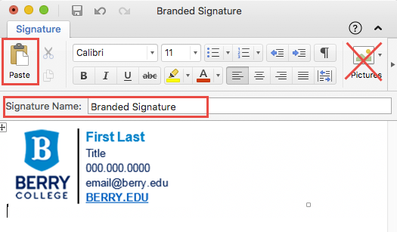

Outlook Web Access (OWA) – mail.berry.edu
- Click on the gear icon in the top right-hand menu and search for “signature”
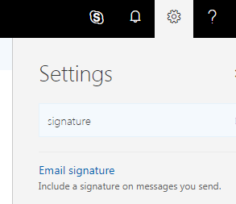
- Select the resulting EMAIL SIGNATURE result to open the configuration window
- NOTE: Outlook Web Access only allows for one signature to be configured
- Copy the signature template from the top of this document per the following instructions:
  - Click inside the text to display the table selection icon at the top left of the signature
  - Click on that icon to select the entire signature (do not remove the empty left column)
  - Right click on any area of the gray highlight and choose COPY from the related menu
- In Outlook 365, place your cursor in the signature area, right click and select PASTE (CTRL V)
- Edit the name and contact information for the signature one line at a time
- Click inside the column to the left of the vertical line to place the selected Berry logo
- Click the INSERT PICTURES icon and choose the preferred logo that was downloaded to your computer
- Click OK to save
